**CG-Assignment**

**Midpoint Circle and Ellipse Algorithms**

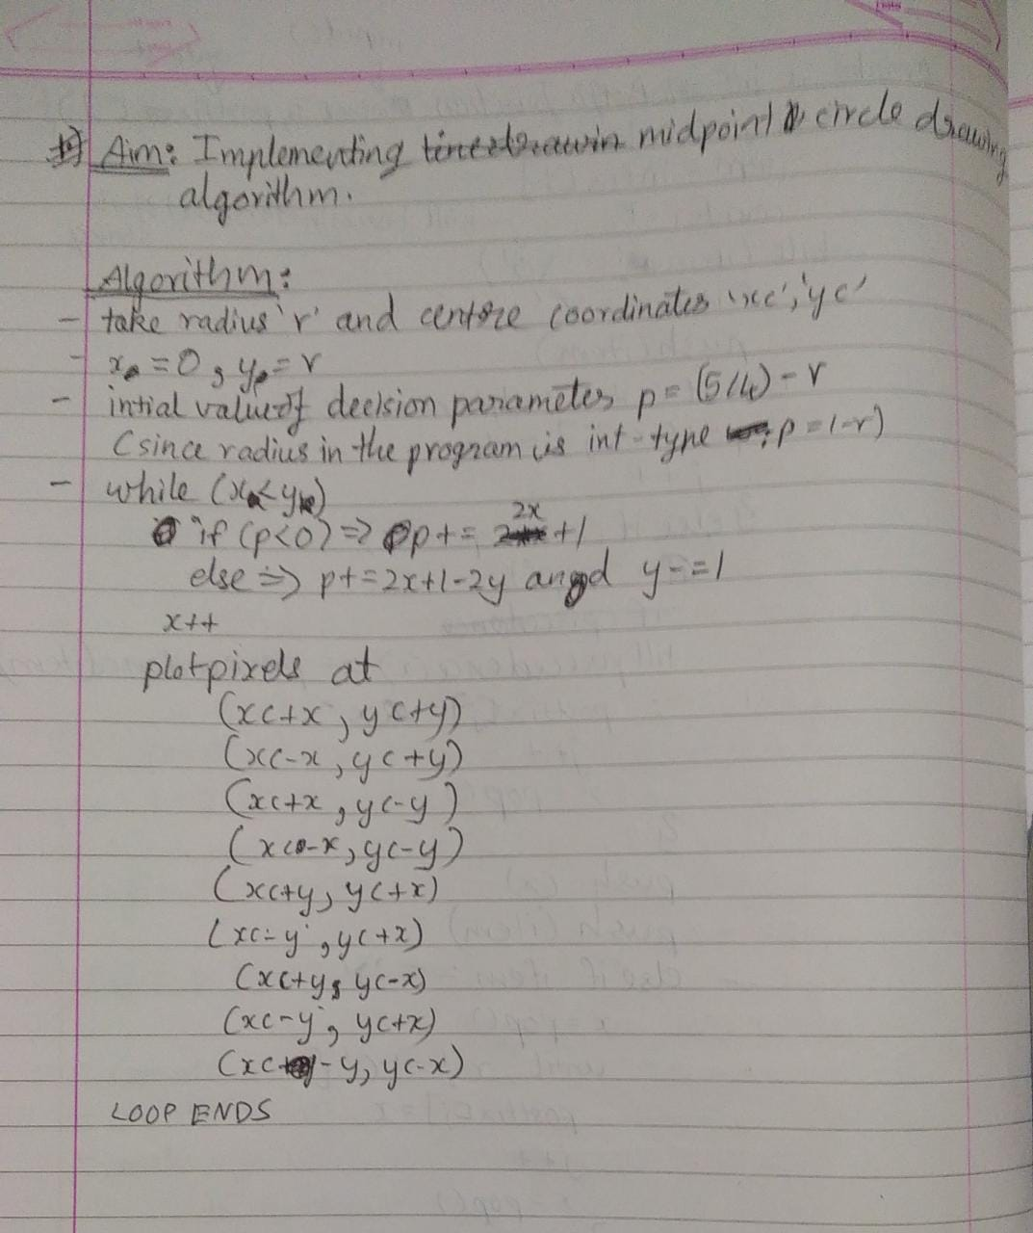

**Program:**

Drawing circles using midpoint circle algorithm

**Code:**

#include<stdio.h>

#include<graphics.h>

#include<conio.h>

void plotPoints(xc,yc,x,y){

putpixel(xc+x,yc+y,WHITE);

putpixel(xc-x,yc+y,WHITE);

putpixel(xc+x,yc-y,WHITE);

putpixel(xc-x,yc-y,WHITE);

putpixel(xc+y,yc+x,WHITE);

putpixel(xc-y,yc+x,WHITE);

putpixel(xc+y,yc-x,WHITE);

putpixel(xc-y,yc-x,WHITE);

}

void mpcircle(int xc, int yc, int r){

int x,y,p;

x=0;

y=r;

p=1-r;

plotPoints(xc,yc,x,y);

while(x<y){

x++;

if(p<0){

p+=2*x+1;

}else{

y--;

p+=2*(x-y)+1;

}

plotPoints(xc,yc,x,y);

}

}

void main(){

int gd = DETECT,gm;

int xc,yc,r;

initgraph(&gd,&gm,"c:\\turboc3\\bgi");

printf("Enter the cneter coordiantes(x,y)\n");

scanf("%d%d",&xc,&yc);

printf("Enter the radius of the circle\n");

scanf("%d",&r);

printf("\nHriday Keswani\nRoll no. 20003088\n");

mpcircle(xc,yc,r);

getch();

closegraph();

}

**Output:**

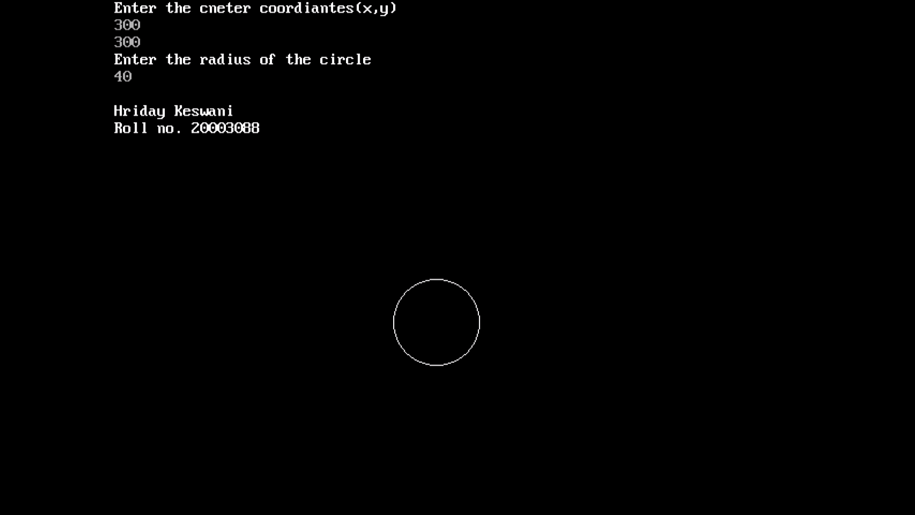

**Program:**

Drawing concentric circles midpoint circle algorithm

**Code:**

#include<stdio.h>

#include<graphics.h>

#include<conio.h>

void plotPoints(xc,yc,x,y){

putpixel(xc+x,yc+y,WHITE);

putpixel(xc-x,yc+y,WHITE);

putpixel(xc+x,yc-y,WHITE);

putpixel(xc-x,yc-y,WHITE);

putpixel(xc+y,yc+x,WHITE);

putpixel(xc-y,yc+x,WHITE);

putpixel(xc+y,yc-x,WHITE);

putpixel(xc-y,yc-x,WHITE);

}

void mpcircle(int xc, int yc, int r){

int x,y,p;

x=0;

y=r;

p=1-r;

plotPoints(xc,yc,x,y);

while(x<y){

x++;

if(p<0){

p+=2*x+1;

}else{

y--;

p+=2*(x-y)+1;

}

plotPoints(xc,yc,x,y);

}

if(r>10){

r-=10;

mpcircle(xc,yc,r);

}

}

void main(){

int gd = DETECT,gm;

int xc,yc,r;

initgraph(&gd,&gm,"c:\\turboc3\\bgi");

printf("Enter the center coordiantes(x,y)\n");

scanf("%d%d",&xc,&yc);

printf("Enter the radius of the circle\n");

scanf("%d",&r);

printf("\nHriday Keswani\nRoll no. 20003088\n");

mpcircle(xc,yc,r);

getch();

closegraph();

}  
  
  
**Output:**  
  
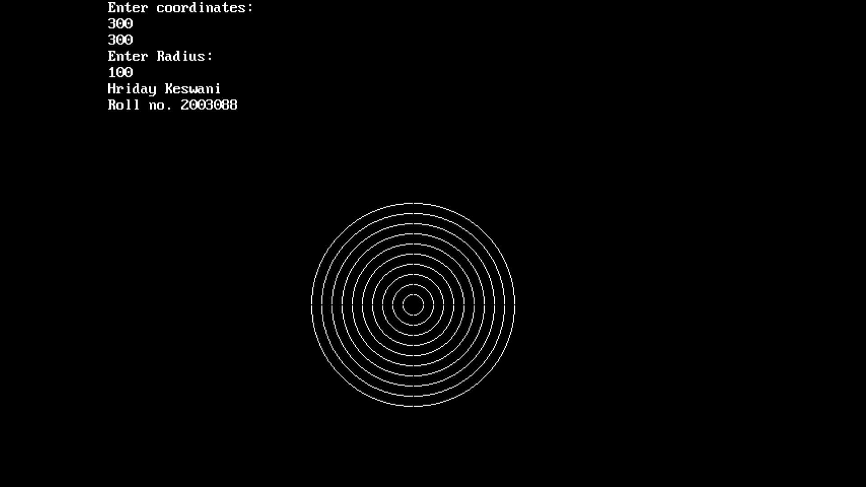

**Program:**

Drawing ellipse from midpoint ellipse algorithm

**Theory:**

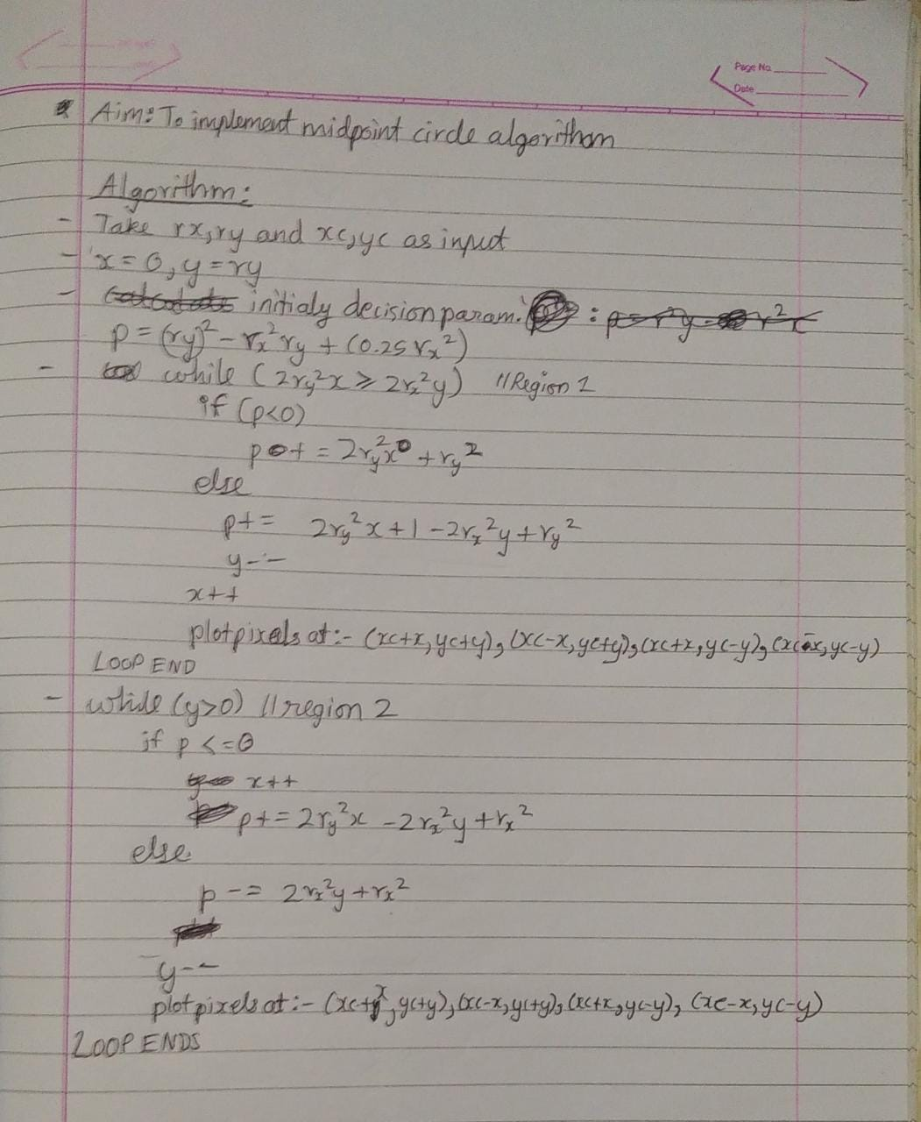

**Code:**

#include<stdio.h>

#include<graphics.h>

#include<conio.h>

void main(){

int gd = DETECT,gm;

int xc,yc,x,y;

long rx,ry;

float p;

initgraph(&gd,&gm,"C:\\TURBOC3\\BGI");

clrscr();

printf("Enter the center coordinates:\n");

scanf("%d%d",&xc,&yc);

printf("Enter Rx and Ry:\n");

scanf("%ld%ld",&rx,&ry);

printf("\nHriday Keswani\nRoll no. 20003088\n");

p = ry*ry-(rx*rx*ry)+(0.25*rx*rx);

x=0;

y=ry;

while(2.0*ry*ry*x <= 2.0*rx*rx*y){

if(p<0){

x++;

p = p+2*ry*ry*x+ry*ry;

}else{

x++;

y--;

p = p+2*ry*ry-2*rx*rx*y-ry*ry;

}

putpixel(xc+x,yc+y,WHITE);

putpixel(xc-x,yc+y,WHITE);

putpixel(xc+x,yc-y,WHITE);

putpixel(xc-x,yc-y,WHITE);

}

p = ry*ry*(x+0.5)+rx*rx*(y-1)*(y-1)-rx*rx*ry*ry;

while(y>0){

if(p<=0){

x++;

y--;

p = p+2*ry*ry*x-2*rx*rx*y+rx*rx;

}else{

y--;

p=p-2*rx*rx*y+rx*rx;

}

putpixel(xc+x,yc+y,WHITE);

putpixel(xc-x,yc+y,WHITE);

putpixel(xc+x,yc-y,WHITE);

putpixel(xc-x,yc-y,WHITE);

}

getch();

closegraph();

}

**Output:**

